**Scalability Testing Hands-on**

1. **Scalability Testing Setup**
2. Make sure you are using **AWS** **Mumbai Region**
3. In AWS EC2 page, scroll down to Autoscaling section and click on Auto Scaling Groups, then click Create Auto Scaling Group

1. Enter name for Auto Scaling Group. (FirstnameASG)

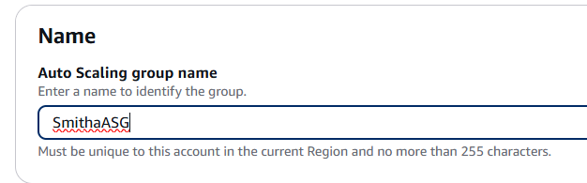

1. Click on Create a launch template.

1. Launch Template creation page will open in a new browser tab. Enter a name for launch template (FirstnameTemp)

1. Search for the image id and select the image.

Image ID: ami-0ac62c3877a5ce135 (Will be available only in AWS Mumbai Region)

1. Select Instance Type as t2.micro. Leave Key pair option as “don’t include”

1. Select “Create security group”. Enter name and description. Click “Add security group rule”

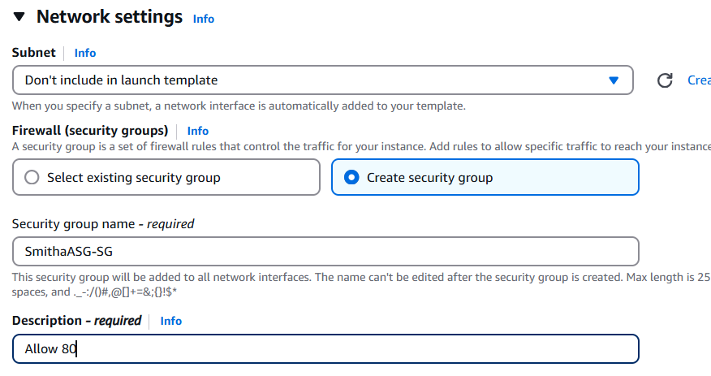

1. Select Type as HTTP and Source type as Anywhere

1. Click “Create launch template”.

1. Now go back to ASG creation browser tab and refresh Launch Template list. Select the newly created template and Click Next.

1. Select the Availability Zones and click Next.

1. Create a new Load Balancer. Enter name (FirstnameASG-LB) and select Internet-facing.

1. Select Listener as “Create a target group” and enter the name of target group (FirstnameASG-TG). Change health check period to 30 seconds. Click Next.

1. In group size and scaling options, select Desired Capacity as 2, Min capacity as 2 and Max Capacity as 5.

In Automatic scaling, select Target tracking scaling policy. Select Metric type as “Average CPU utilization”, Target value as 5 and Instance warmup as 30 seconds.

1. Select “Enable group metrics collection within CloudWatch” and click Next.

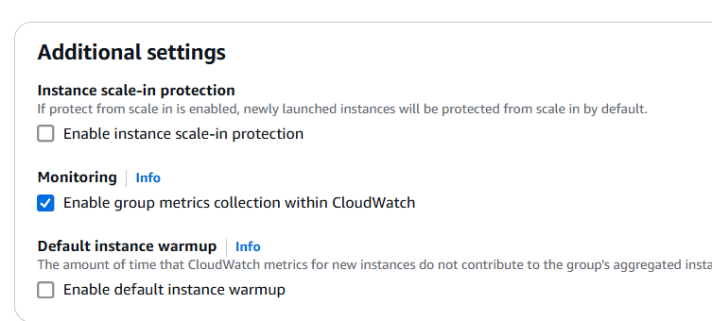

1. Click Next on Notifications and Tags and Click on “Create Auto scaling group” on the Review Step.

1. Once the status of ASG becomes “–”, then go to Load Balancer, copy the DNS name, and access the server.



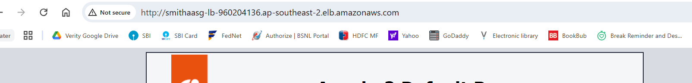

1. Refresh the page to see the load balancer accessing different instances.
2. Terminate an instance and watch it getting replaced by a new one. Note the change in the ip address getting displayed.
3. Apply load to see the new instances created and destroyed.
4. **Clean up.**
   1. Delete the Auto Scaling Group.
   2. Delete the Load Balancer.
   3. Delete the Target Group.
   4. Delete the Launch Template.
5. **Scalability Testing**
   1. Log in to <http://localdb-1474497026.ap-southeast-2.elb.amazonaws.com/CollegeMgmt> with credentials [superuser@demo.com](mailto:superuser@demo.com) / 123456
   2. Test and note down issues.
   3. Log in to <http://rdslb-205751401.ap-southeast-2.elb.amazonaws.com/CollegeMgmt> with same credentials and test and note down issues.